**Nada Musyaffa Bilhaqi**

**245150400111035**

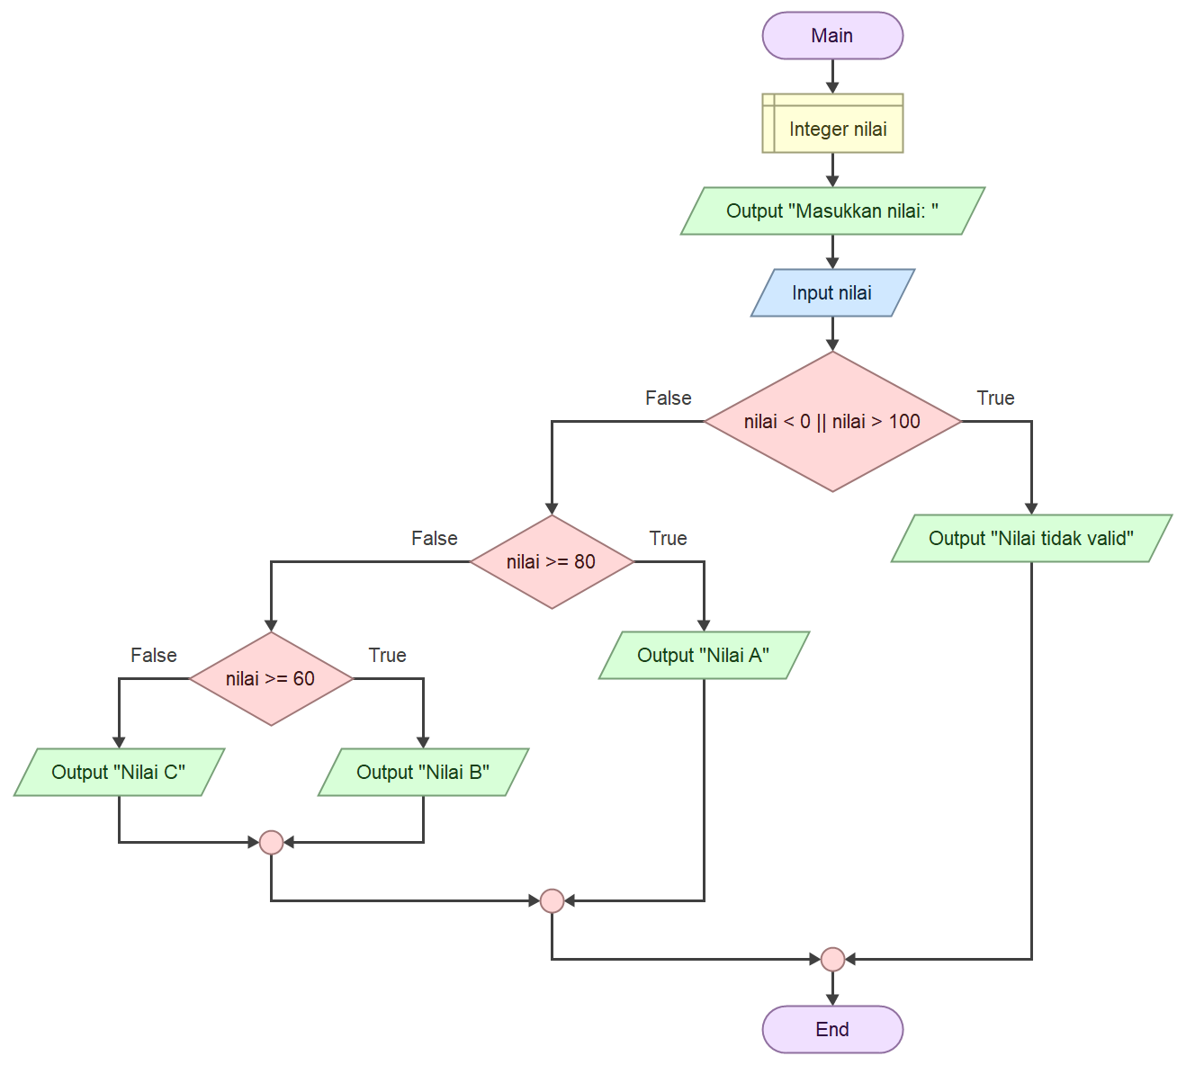

import java.util.*;

public class Nilai {

public static void main(String[] args) {

int nilai;

Scanner input = new Scanner(System.in);

System.out.println("Masukkan nilai: ");

nilai = input.nextInt();

if (nilai < 0 || nilai > 100) {

System.out.println("Nilai tidak valid");

} else if (nilai >= 80) {

System.out.println("Nilai A");

} else if (nilai >= 60) {

System.out.println("Nilai B");

} else {

System.out.println("Nilai C");

}

}

}

